**Python exception handling exercise**

Write a Python Program using tkinter which will implement 2 user intrface:

Interface 1 will handle login for users.

Interface 2 will then allow users to check their status of an excursion depending with the amount they have in the bank account and also handle the exceptions.The program should allow the user to enter the amount that she/he has. If amount is less than 3000 raise a valuerror and display in a label or message-box the following message: “Please deposit more funds for this excursion.

If the amount entered is greater than 3000 display : You qualify for the Malaysia trip. Congratulations.

Example of the first login screen:

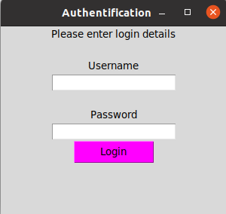

If the username and password is correct, call a module to do the error handling. You are expected to use a dictionary to store your usernames and passwords. (At least four usernames and four passwords).

The second interface may look as below (but you can deviate depending with how you want to solve the problem)

